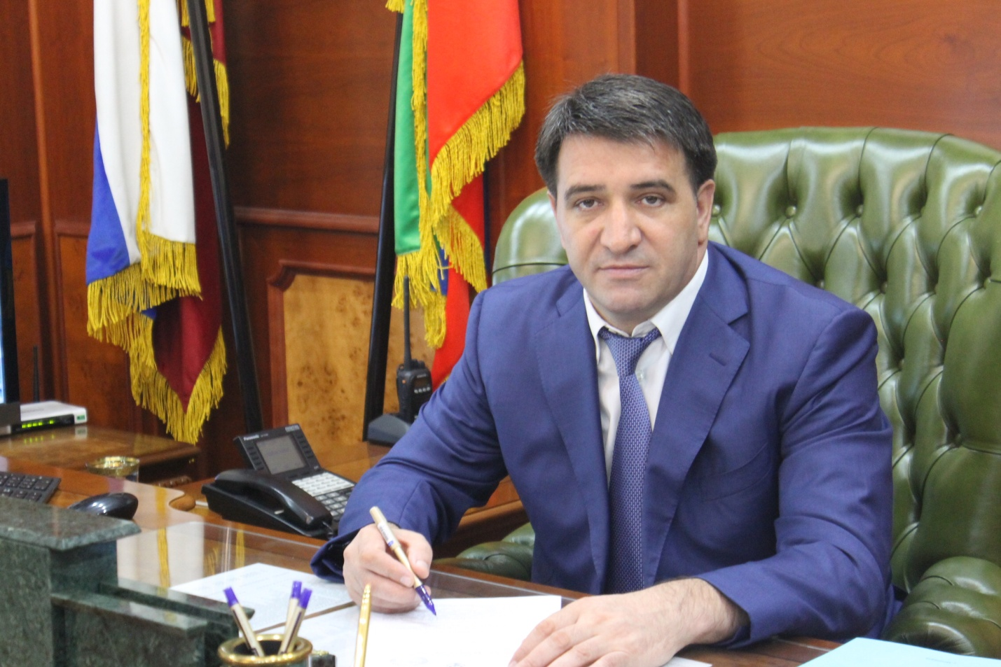

Investment message of the head
Municipality
Khasavyurtovskiy rayon Slavova D. S.
2018 year
Since 2015, we have put into practice a new direction – the Investment address, the main purpose of which is to determine the range of main activities and steps to create a favorable business investment climate in our area.
Investment message is a program document that complements the Strategy of socio – economic development of the municipality "Khasavyurt district" for the period up to 2020.
The purpose of the address is to inform the participants of the investment process about the investment policy in Khasavyurt district, the planned key measures to improve the investment climate in our region. Currently, the topic of attracting investment is becoming one of the most discussed at both the Federal and regional levels. At the same time, we must remember that when the issue of increasing the volume of investments in the economy of any region is raised, it is about attracting investors to the site of a particular municipality. Therefore, success in working with investors depends on the local authorities, on how the system of support for investment activities and attraction of investments in the field is built.
The main purpose of the investment policy of Khasavyurt district is to increase the diversity of key sectors of the economy that determine the competitive advantages of the district through the use of external
and domestic investment and the formation of a favorable business climate throughout the district.
Attracting investment in the economy of the district is one of the strategic objectives of the municipal district administration.
The growth of investments directly affects not only the increase in tax revenues, the creation of new jobs, but also the level and quality of life. Therefore, we need to create comfortable conditions for entrepreneurs and a favorable investment climate aimed at increasing the attractiveness of the area. For these purposes, created and approved by the Council to improve the investment climate and support of investment projects and expert selection of strategic projects at the head of the municipality, the decision of the Assembly of deputies of the municipal district approved the regulations "On tax benefits on local taxes for legal entities and entrepreneurs engaged in investment activity on the territory of municipal district", prepared and approved the plan for the investment of infrastructure facilities of the district for 2018, the list of services provided by the administration of MO "Khasavyurt district" or subordinated municipal unitary enterprises and institutions in the course of work with investors has been compiled and approved.
According to the main indicators of socio-economic development Khasavyurt district looks decent against the background of other regions of the Republic of Dagestan.
State statistics show that the district is intensively increasing the pace of development in almost all sectors of the economy and social sphere:
Thus, the growth rate for January-June 2018 compared to the same period in 2017 amounted to:
industrial production -13 %,
agricultural products – 1,8 %,
retail trade turnover-1,2 %,
the volume of paid services to the population-1.2%,
turnover of small and medium-sized businesses-1.2%,
tax and non-tax revenues of the municipal district budget-24 %.
The average monthly salary of employees in the area for January-June 2018 amounted to-20273 rubles, which is 2974.2 rubles more than in 2017.
The volume of investment in fixed assets from all sources of financing in the first half of the year amounted to 427.5 million rubles, or 15.7% of the annual target (forecast for 2018 – 2719 million rubles.)
New economic entities are opening in the district, which create new jobs. In total, 395 seats were created in the first half of the year, against 188 seats for the same period in 2017.
However, despite the positive results, it is important to note a number of outstanding issues. The amount of investment that comes to the district today is not enough for the active development of the economy. The lack of investment does not allow to form their own sources of income for the development of the social sphere. The existing problems are a serious obstacle to the development of the investment potential of the region;
- limited access to Bank credit resources-Bank financing does not solve the problems of development of small and medium-sized businesses
due to the lack of adequate collateral, non-transparency of financial flows of small businesses, caution of banks in lending to small businesses;
- for most small businesses is a typical situation with a shortage of workers of the right skills, equipment of the right quality, facilities.
Therefore, we need to create conditions for the work of subjects of all categories of business (from small to large) and a favorable investment climate.
To achieve the above-mentioned objectives, an action Plan was approved
to implement the Strategy of socio-economic development of the administration of MO "Khasavyurt district" until 2025 for 2016-2020", developed a "Road map" for the implementation of the Standard of the district administration to ensure a favorable investment climate in the municipal district "Khasavyurt district".
In the field of investment policy, we set ourselves the following tasks for the future:
- building the investment potential of the district;
- attraction of investors for creation of new, and also expansion and modernization of the existing industrial and agricultural enterprises in the territory of the area;
- implementation of The standard of the district administration to ensure a favorable investment climate in the Khasavyurt district;
- promotion of products, works and services produced on the territory of the municipal district to the regional and interregional level by organizing the participation of enterprises of the district in national and interregional competitions.
- there should be available infrastructure to accommodate production and other investment projects. For this purpose, it is necessary to update annually the register of land plots ready to place investors for the implementation of projects in the field of agriculture and industry. Moreover, all urban planning documents, schemes for the development of engineering and road infrastructure should be up to date, and comply with the plans for the placement of investment projects.
The priority direction of the investment policy of the administration of Khasavyurt district was and remains the implementation of measures to improve the socio - economic situation in the area-is the gasification of settlements, water supply, construction of preschool institutions, schools, district hospital, FAPs.
The key sectors in which we will attract investment will be agriculture, construction, medicine and education.
I would like to touch upon one of the most important factors affecting the favorable investment climate – human resources. In recent years, in the region, as in the Republic as a whole, there is a decline in the prestige of primary vocational education, technical education, respectively, there is an imbalance of the labor market and the market of educational services. Higher education remains prestigious despite the needs of the labour market.
Analysis of the professional composition of the unemployed shows that the least in demand in the labor market: accountants, economists, lawyers. Increased demand in the labor market enjoyed: teachers, machine operators, doctors and nurses. We are ready to consider business proposals to provide human resources for the implementation of priority investment projects.
Summing up the results of my address, I cannot but note the problems faced by our municipality in working with investors and attracting investment - this is:
a) limited municipal support measures for the investor, due to the scarcity of local budget;
b) lack of qualified personnel (both workers and specialists in working with investors).
It is necessary to increase the information openness of the district in terms of creating a positive investment image. We must speak as widely as possible about the area, its capabilities and potential. To do this, there are a lot of tools: presentations, exhibition and fair activities, placement of information materials and interviews about the investment potential of the district in the print media and online publications. A series of such events we are already doing, on the website of the district administration has portal "investment activity", where you placed the investment strategy of the municipality to 2020, the investment passport of the municipal entity, the plan for the investment of infrastructure facilities of the district for 2018.
Special attention should be paid to young people - it is the basis for the future development of the municipal district.
It is necessary to create more opportunities to improve the educational level, the organization of cultural and sports leisure of young people, self-realization of the younger generation within the district, solving the housing problem.
Behind all the achieved figures and results noted in the address, there is a huge work of collective of administration of the area, heads and employees of administrations of settlements, collectives of municipal institutions and all asset in General.
Today we are summing up the results of the half-year and note not only the achievements, but also set tasks for the future. This is a purposeful work to increase the tax base and increase their own revenues of the budgets of settlements and the district budget, the creation of new jobs, increasing wages, attracting investment in the area, the construction of production facilities and social facilities, repair and construction of roads, and other equally important tasks that will allow residents to live better and more comfortable Their decision is possible only at joint and effective work of local governments, the enterprises, establishments and the organizations of the area.
I Express my gratitude to all my colleagues, deputies, heads of organizations and institutions, heads of settlements for interaction and cooperation.

Welcome to Khasavyurt district.

