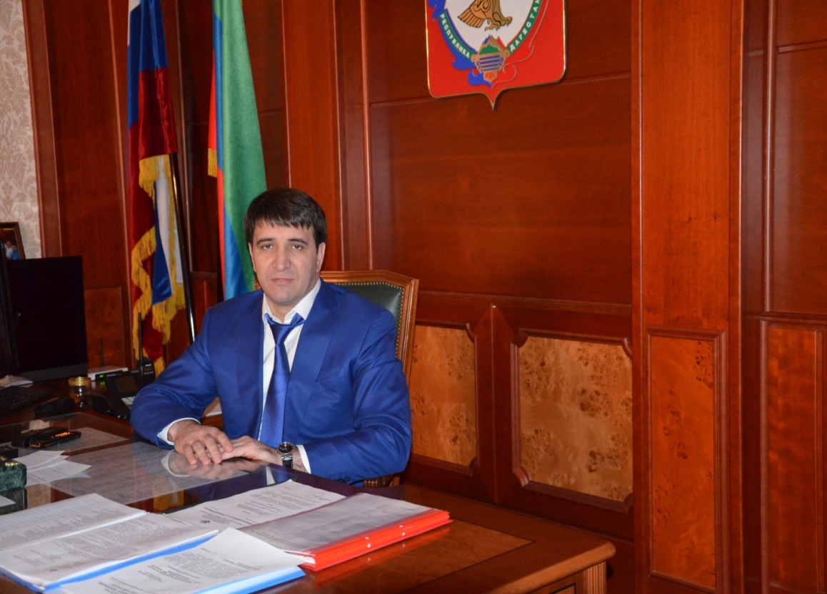

Investment message of the head
Municipality
Khasavyurtovskiy rayon Slavova D. S.

Starting from this year, we are putting into practice a new direction – an Investment message, the main goal of which is to determine the range of main activities and steps to create a favorable business investment climate in our area.
Investment message is a program document that complements the Strategy of socio-economic development of the municipality "Khasavyurt district" for the period up to 2020.
The purpose of the message is to inform the participants of the investment process about the ongoing investment policy in Khasavyurt district, the planned key measures to improve the investment climate in our district. Currently, the topic of attracting investment is becoming one of the most discussed at both the Federal and regional levels. At the same time, it should be remembered that when the question of increasing the volume of investments in the economy of a region is raised, it is about attracting investors to the site of a particular municipality. Therefore, success in working with investors depends on local governments, on how the system of support for investment activity and attraction of investments on the ground is built.
The main objective of the investment policy of Khasavyurt district is to increase the diversity of the supporting sectors of the economy that determine the competitive advantages of the district through the use of external
and domestic investment and the formation of a favorable business climate throughout the district.
Attraction of investments in the economy of the district is one of the strategic objectives of the municipal district administration.
The growth of investments directly affects not only the increase in tax revenues to the budget, the creation of new jobs, but also the level and quality of life. Therefore, we need to create comfortable conditions for entrepreneurs and a favorable investment climate aimed at increasing the attractiveness of the district. For these purposes, created and approved by the Council to improve the investment climate and support of investment projects and expert selection of strategic projects at the head of the municipality, drafted and approved the plan for the investment of infrastructure facilities of the district for 2015, compiled and approved the list of services provided administration of municipal formation "Khasavyurt district", or subordinated to the municipal unitary enterprises and institutions in the course of work with investors.
According to the main indicators of socio-economic development Khasavyurt district occupies a leading position in many areas and looks decent against other regions of the Republic of Dagestan.
State statistics show that the district is intensively increasing the pace of development in almost all sectors of the economy and social sphere:
Thus, the growth rate for January-June 2015 compared to the same period in 2014 amounted to:
Industrial production-5%,
agricultural production-1.7 times,
investment in fixed assets of 8.3%,
construction-7,0%,
commissioning of residential buildings-7.0%.
retail trade turnover and 2.9%,
the volume of paid services to the population-5.2%,
turnover of small and medium-sized businesses-5.3%.
The average monthly salary of employees in the district for January-June 2015 amounted to 15,867.4 rubles, which is 269.4 rubles more than in 2014.
The volume of investments in fixed assets due to all sources of financing in the first half amounted to 374.4 million rubles, or 19.7% of the annual task (forecast for 2015 – 1893.0 million rubles.)
New economic entities that create new jobs are opening up in the district. In total, 283 seats were created in the first half of the year, against 55 seats for the same period in 2014.
The growth rates of investments indicate that the district is moving forward with confidence.
However, despite the positive results, it is important to note a number of outstanding problems. The volume of investments that are coming to the district today is insufficient for the active development of the economy.
Lack of investments does not allow to create own profitable sources for development of the social sphere as much as possible. The existing problems are a serious obstacle to building the investment potential of the district;
- limited access to Bank credit – Bank financing does not solve the problems of small and medium-sized businesses
due to the lack of proper collateral, non-transparency of financial flows of small businesses, banks ' caution in lending to small businesses;
- for the majority of small businesses, the situation remains typical with a shortage of workers with the necessary skills, equipment of the required quality, premises.
Therefore, we need to create conditions for the work of subjects of all categories of business (small to large) and a favorable investment climate.
In order to achieve the above – mentioned objectives, a "program of economic and social development of the district for 2014-2018" was adopted, this year a "Road map" was developed to implement The standard of the district administration to ensure a favorable investment climate in the territory of the municipal district "Khasavyurt district".
In the sphere of investment policy, we set the following objectives for the future:
- building investment potential of the district;
- attraction of investors for creation of new, and also expansion and modernization of the existing industrial and agricultural enterprises in the territory of the area;
- implementation Of the standard of the district administration to ensure a favorable investment climate in the territory of Khasavyurt district;
- promotion of products, works and services made in the territory of the municipal area to the regional and interregional level by the organization of participation of the enterprises of the area in Republican and interregional competitions.
- there must be an accessible infrastructure for the placement of production and other investment objects. To do this, it is necessary to annually update the register of land plots that are ready to accommodate investors for the implementation of projects in the field of agriculture and industry. Moreover, all urban planning documents, schemes of development of engineering and road infrastructure should be up to date, and comply with the plans for the placement of investment projects.
The priority direction of investment policy of administration of the Khasavyurt area was and remains carrying out actions for improvement of a social and economic situation in the area is a gasification of settlements, water supply, construction of preschool institutions, schools, regional hospital, FAPs.
The key sectors in which we will attract investment will be agriculture, construction, medicine and education.
I would like to touch upon one of the most important factors influencing the favorable investment climate – labour resources.
In recent years, in the region, as in the Republic as a whole, there has been a decline in the prestige of primary vocational education, technical education, respectively, there is an imbalance in the labor market and the market of educational services. Higher education remains prestigious against the needs of the labour market.
Analysis of the professional composition of the unemployed shows that the least in demand in the labor market: accountants, economists, lawyers. Teachers, machine operators, doctors and nurses were in high demand in the labor market. We are ready to consider offers of business on providing with manpower for implementation of priority investment projects.
Summing up the results of my address, I cannot but note the problems faced by our municipality in working with investors and attracting investment-it:
a) limited municipal support measures for the investor, due to the scarcity of local budget;
b) shortage of skilled personnel (both workers, and experts in work with investors).
It is necessary to increase the information openness of the district in terms of creating a positive investment image. We need to talk as widely as possible about the area, its capabilities and potential. For this purpose, there are a lot of tools: presentations, exhibition and fair activities, placement of information materials and interviews about the investment potential of the district in print media and online publications. A number of such events we are already carrying out, on the site of the district administration there is a portal "investment activity", where the investment strategy of the municipality until 2020, the investment passport of the municipality, the plan of investment infrastructure of the district for 2015, a list of services provided by the administration of MO "Khasavyurt district", or subordinated municipal unitary enterprises and institutions in the course of working with investors.
Special attention should be paid to young people - it is the basis for the future development of the municipal district.
It is necessary to create more opportunities to improve the educational level, the organization of cultural and sports leisure of young people, self-realization of the younger generation within the district, the solution of the housing problem.
Behind all achieved figures and the results noted in the message, there is a huge work of collective of administration of the area, heads and employees of administrations of settlements, collectives of municipal authorities and all asset as a whole.
Today we sum up the results of the first half of the year and note not only the achievements but also the challenges ahead. It is purposeful work on increase of tax base and increase of own revenues of budgets of settlements and the district budget, creation of new workplaces, increase of a salary, attraction of investments to the area, construction of production facilities and objects of the social sphere, repair and construction of roads, and other not less important tasks which will allow to live better and more comfortably to inhabitants of our area. Their decision is possible only at joint and effective work of local governments, the enterprises, establishments and the organizations of the area.
I Express my gratitude to all my colleagues, deputies, heads of organizations and institutions, heads of settlements for cooperation.

Welcome to Khasavyurt district.

